Computer Language Coding Concepts

Symbol in a Diagram
The concept of the term symbol is explained in the article Symbol. The current article demonstrates it in a diagram.

The same related item or related list item can be displayed on screen multiple times, when the parent object is displayed on screen multiple times.

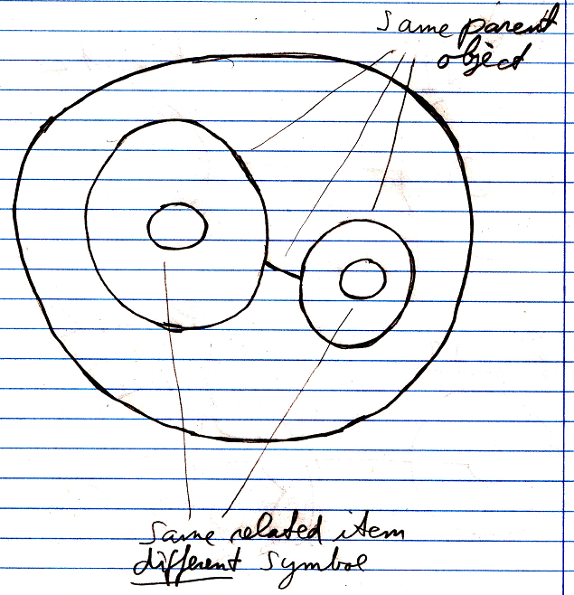

In that case multiple symbols are there for the same related item or related list item. So a symbol is a separate entity.

The term symbol was once confused as being a synonym for related object or object reference. If the term symbol was synonymous for related item, then the idea that opening up a symbol’s system interface:

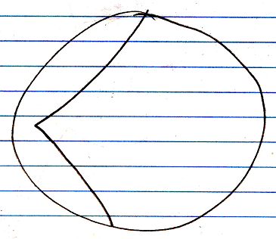

was like opening up the inner workings of a symbol. (See the article System Interface.) And the system interface was supposed to be part of the symbol, rather than part of the object itself:

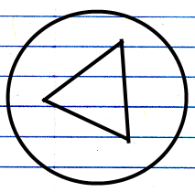

It being that you are not opening up the inner workings of a symbol, but opening up the inner workings of a related item, sort of ruins that a little bit.

But the notation for opening up the system interface still works ok and is still a clear expression.

See also: System Objects, Symbol

Author & Copyright: Jan-Joost van Zon Date: July 18, 2008 – July 18, 2008 Location: Oosterhout, The Netherlands Status: Finished

